Customize Download Settings fields by clicking your account name on the dropdown menu, next click on Settings, then click the Download Settings tab.

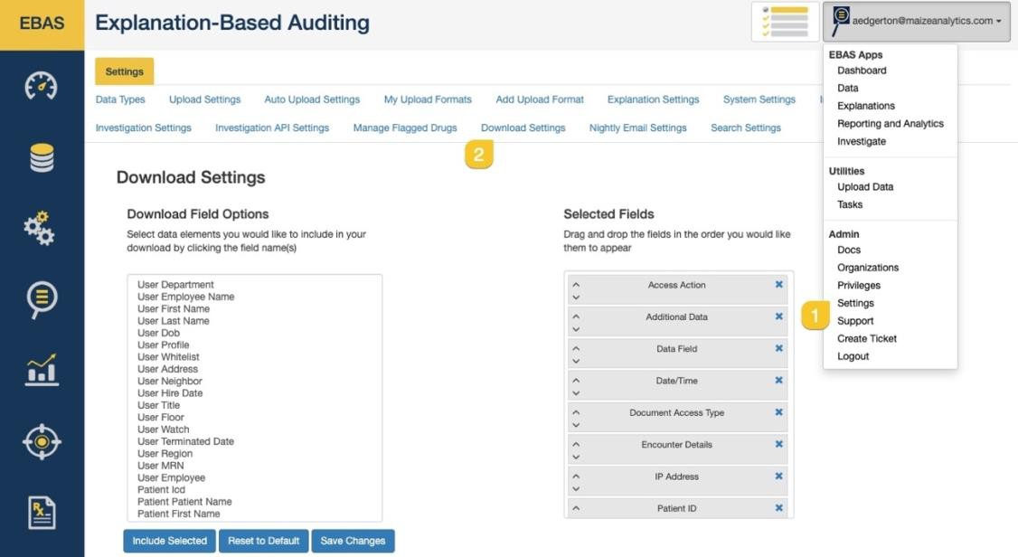

Choose the fields you would like to include in your download by clicking on the field name, you can include multiple fields by clicking and holding control or command ⌘ if you are using a Mac. Once you have selected the fields you'd like to include, click Include Selected.

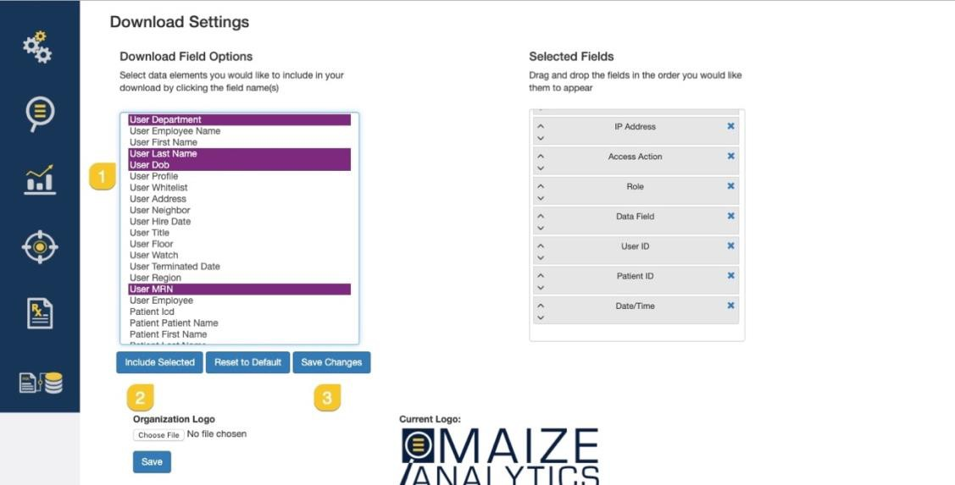

If you would like to organize the order your fields are displayed in your CSV you can click and drag the data fields in the right column to place them in the order you prefer.
Save your changes once you have solidified the order of your data fields.
